

**Money and Credit: Banking and the Macroeconomy**

Speech given by

Paul Tucker, Executive Director, Markets and a Member of the Monetary Policy Committee, Bank of England

At the Monetary Policy and the Markets Conference, London 13 December 2007

My thanks for comments and/or for background work to Peter Andrews, Charlie Bean, Tim Besley, Roger Clews, Andy Haldane, Colin Miles, James Proudman and Iain de Weymarn. Special thanks to Jing Yang and Alex Haberis. For comments and background work to Damien Lynch. And for secretarial support to Sandra Bannister and Cheryl Feeney.

1

All speeches are available online at [www.bankofengland.co.uk/publications/Pages/speeches/default.aspx](http://www.bankofengland.co.uk/publications/Pages/speeches/default.aspx)

# MONETARY POLICY AND THE MARKETS CONFERENCE MONEY AND CREDIT: BANKING AND THE MACROECONOMY

Each month the MPC sets a policy rate, Bank Rate, that will prevail until our next policy meeting. But no one – here today, in the market, or on the Committee – thinks that setting the overnight money market rate for the coming 30 days can be enough to steer demand conditions and maintain stable inflation. Rather, policy works on the basis of expectations of the path of the Bank Rate in the future, and of how our policy settings will vary according to economic conditions: the so­called ‘reaction function’.

Perceptions of the reaction function therefore matter a lot and a great deal of effort goes into being transparent about the three inputs: the Committee’s objective; the MPC’s views on the shocks to demand and supply affecting the economy; and our views on how the economy works and how our policy settings affect it. This conference is focused on one important element of this: the role of financial markets in the setting and transmission of monetary policy. That is covered in the Bank’s publications on how the economy works, including the Committee’s 1999 paper on the Monetary Transmission Mechanism (MTM), and books describing the models used in forecasting.1 But those high­level descriptions miss out an awful lot about how the real and financial parts of the economy connect. Financial variables are limited to the short­term interest rate, the exchange rate, and equities. Nothing on the role of long­maturity interest rates, or on credit spreads and risk premia – which misses out a whole universe of financial asset prices.

Very little on credit more generally. Next to nothing on money. And nothing at all on the role of bank intermediation.

These gaps were perhaps underlined by a degree of confusion amongst commentators about the way in which Money and Credit featured somewhat more prominently in the Committee’s discussions during the backend of 2006 and into this year (Chart 1). With both having been strong for a while, some asked whether this marked some kind of change in the reaction function, implying a greater stress on nominal variables.

Given the near identity of deposits and bank lending, Money and Credit are often used almost inseparably, even interchangeably, with wider measures of non­bank credit looked at only when assessing the health of corporate and household sector balance sheets. But in some

circumstances one can do better to approach things the other way round, starting with general credit conditions, examining the interactions of non­bank and bank lending, and then broad money as a (partial) counterpart to M4L. My remarks today will follow that structure, which will provide a framework for some observations about the current tightening in credit conditions, as well as about the preceding expansion.

# Credit

Credit is, of course, vital to any economy, enabling households and firms to make choices about whether to bring forward or defer spending from income. There are conditions in which it would play no active role, passively reflecting cyclical fluctuations in output, employment and inflation. In a world of more or less complete transparency between borrowers and lenders, very low transactions costs, and very low risk aversion, access to credit would not be rationed; and ex ante yields on financial assets, including loans and bonds, would not embody risk premia. So if households and firms wanted to bring forward spending in the face of shocks to the economy, they would be able to do so restricted only by their need to remain solvent.

But nobody believes that that is a description of the real world in which households and companies manage their affairs. Both are, to a greater or lesser degree, rationed in their access to credit, given that borrowers know a great deal more about their conditions and prospects than do risk­averse lenders, and that lenders face obstacles in ensuring that borrowers honour their contracts.2 The availability, price and terms of credit– whether unsecured or secured – will be sensitive to a range of factors, including assessments of the idiosyncratic risks of a particular borrower, and the risks common across borrowers. Variations in these factors give rise to the possibility of a credit cycle.

A borrower’s ability to pledge collateral can help to overcome the problems of ‘asymmetric information’ and enforceability, by evidencing its net worth and giving it a continuing stake in its contract with the lender. This can give rise to the so­called ‘financial accelerator’ channel of the Monetary Transmission Mechanism (MTM), in which monetary policy works partly by affecting lending terms through its effect on asset values and so the net worth of borrowers.3

But credit conditions also depend on the access to credit of the *lenders* themselves. There is an important distinction here between intermediation across bank balance sheets and via the capital markets, although as I shall describe it turns out to be blurred.

# Total credit: capital markets and securitisation

For the moment, I shall put that distinction to one side in order to focus on total credit. A series of environmental changes over the past decade or so have affected the quantity and price of credit generally. Greater macroeconomic stability, and perceptions that it will persist more or less uninterrupted, probably increased the supply of credit; and by reducing risk premia, may have increased demand too (Diagram A)

Other developments are more likely to have worked purely through credit supply. The most obvious is the growth of instruments such as credit derivatives and securitisation, associated with an increased role for rating agencies in monitoring credit risk. This was in effect a shock to technology, making portfolios transferable. By offering the prospect of better meeting desired risk profiles and by separating origination from investment, it has brought more non­bank financial institutions, and so more capital resources, into the credit markets, increasing the supply of credit (Diagram B).

This seems to have been borne out in the significant shift in actual credit quantities and prices up to the middle of this year.

In the United Kingdom, non­bank lenders have accounted for a greater share of credit extension to both the household and corporate sectors (Charts 2­4).

A lot of that has been securitised (Chart 5). For the household sector, spreads on securitised portfolios of both secured and unsecured credit fell between 2003 and 2005 (Chart 6). That will have contributed to the fall in effective rates on the underlying mortgages and personal loans (Chart 7).

The same broad picture holds for the corporate sector (Chart 8). An illustrative decomposition suggests that, especially for sub­investment grade borrowers, the compression of spreads could

not be explained solely by reduced compensation for default risk, with the excess possibly reflecting lower liquidity premia (Chart 9).4

These falls in spreads were material relative to the changes in the MPC’s Bank Rate and to the risk­free yield curve. For example, in the latest ‘policy cycle’, we increased Bank Rate by 125bp over 11 months from August 2006. During that period, effective rates on new mortgages rose by closer to 50bp. In other words, from around 2003, monetary policy needed to take account of a progressive loosening of credit conditions.

The tables have now turned. Spreads have risen; the issuance of securitised portfolios of household loans has collapsed; corporate bond issuance has fallen (Charts 10­11). It is pretty clear that, for the time being, there has been an adverse shift in the supply of credit from the non­ banking sector. In part, that seems to be due to investors becoming less confident that they can base decisions about exposures to complex credit portfolios on rating agency ratings; this is akin to lenders deciding that their monitoring of risk was less good than they thought. In part, it is due to various types of non­bank investor in credit finding themselves facing actual or incipient liquidity pressures. Both as cause and effect, liquidity in the capital markets is impaired. This is apparent in the opening up of a so­called ‘negative basis’ between the spreads on corporate bond and on equivalent credit­default swaps, which unbundle the transfer of credit risk from the provision of funds and so are less affected by liquidity hoarding (Chart 12).

*A twin­engine financial system?*

At various times over the past decade or so, it had been argued5 that the macroeconomy as a whole should be more resilient to shocks to a financial system with ‘twin engines’ – combining capital markets with banking system intermediation of savings and credit. The argument is that when the capital markets are impaired, banking can take more of the burden, and vice versa. I have a good deal of sympathy for this view – but not for all circumstances. It rather overstates the independence of capital markets and banking, as recent developments graphically demonstrate.

First, whether through financing the purchase of credit assets by leveraged funds or warehousing portfolios prior to sale or providing ‘liquidity lines’ to conduits and other investment vehicles, the banking system puts its capital and liquidity behind the distribution of credit risk to the wider

asset­manager universe. As the official sector stressed over recent years, it is important to be clear about the circumstances in which risk can flow back to the banking system.6

Second, the ‘twin engines’ view draws too absolute a line between banks and non­bank financial intermediaries. Alongside other asset managers, banks have been material investors in securitised credit. In some respects, it may be more useful to distinguish between intermediaries on the basis of whether they undertake some combination of maturity transformation, leveraging their balance sheets, and mark­to­market valuations. Banks are not alone in having these characteristics, and so there can be common shocks to bank and non­bank investors. In a recent series of papers,7 Hyun Shin has argued that balance sheet management of this kind amplifies the credit cycle. That sounds like the ‘financial accelerator’ model, except that Shin’s position is that the outcomes can exceed those warranted by fundamentals. His argument is that in the upswing of a business cycle, the rise in asset values increases the accounting net worth of banks and other intermediaries, enabling them to leverage up their balance sheets. This expands credit; and increases the liquidity in capital markets, reducing liquidity premia embodied in asset prices; and so on. And when the music stops, the process can be reversed as falls in asset values, leverage and liquidity feed on each other. (For Shin, the villain is mark­to­market accounting, although I would not want its virtues in reducing forbearance to be overlooked.)

Thirdly, the ‘twin engines’ view may place insufficient weight on banks having remained the principal originators of credit, given that small firms and households cannot issue bonds directly into the capital markets. It has been argued that the growth of markets for securitising loan portfolios made banks less relevant to overall credit conditions, and so to the business cycle, because a bank’s ability to originate credit becomes less intimately bound up with its own financial strength.8 But if, as currently, the capital markets’ appetite for securitised credit diminishes, a larger proportion of loans will after all remain on the balance sheets of banks.

All this brings back into focus the potential macroeconomic relevance of bank lending.

# Bank lending

The economic literature on the ‘bank lending’ channel of the Monetary Transmission Mechanism explores the conditions under which a tightening of monetary policy causes the terms on bank lending to tighten over and above the increase in risk­free short­term real rates. The literature

has typically assumed (i) that a monetary policy tightening is effected by the central bank withdrawing reserves from the system (or slowing the pace of reserves injection); (ii) that banks are required to hold a proportion of transactions deposits in reserves, so that reduced reserves provision entails slower deposit growth; and (iii) that they do not have unrestricted access to liabilities that are not subject to reserves requirements, and so cannot fill the gap left by slower deposit growth and must, instead, slow loan growth, which they do by tightening credit conditions.9 The first two steps seem archaic. We effect monetary policy changes by controlling the price not the quantity of central bank money in the system; and, in the UK, banks choose their own reserves targets rather than having them determined by a balance sheet ratio of some kind.

But the third plank in these models – restricted access to non­deposit liabilities, whether capital­like or not – plainly is still relevant today. In a world of asymmetric information, banks do not have unrestricted access to resources, and we do not believe that a bank’s lending behaviour is invariant to its capital gearing or to the composition of its liabilities.10 We do, therefore, face questions about the extent to which a shock to banks’ liquidity or capital resources can bring about a shift in credit conditions with macroeconomic effects that, other things being equal, monetary policy should seek to offset in order to maintain aggregate demand in line with aggregate supply.

Over the past 15 years or so, when banks have seemed anything but restricted, easier access to liquidity or capital may have brought about a progressive relaxation of bank lending conditions. That this featured in commentary on monetary policy rather less than the recent manifest tightening may say no more than that sharp contractions attract more attention than gradual expansions. In a similar vein, on the whole, research does better at identifying these ‘credit channel’ mechanisms in the context of particular stressed episodes than in longer­run averages.11

Be that as it may, it is beyond doubt that there has recently been an adverse shock to bank balance sheets – involving capital, liquidity, and a potent ‘asymmetric’ information mechanism affecting a wide range of banks. I will pick out four elements in the story, involving liquidity, counterparty­credit risk and capital.

First, near closure of the capital markets for leveraged loans, conduit and SIV commercial paper, and RMBS has left banks whose business model is ‘originate and distribute’ unexpectedly

holding on to loans and, in addition, facing the prospect of having to take assets back on to their balance sheets. The consequent reintermediation is a hit to both capital ratios and liquidity, as the banks have bigger books to fund. For these reasons alone, big picture, banks responded from August onwards by tightening loan terms and hoarding liquidity.

But the story does not end there. The second element is that access to resources (uninsured deposits) from outside the banking sector has become more restricted since the summer. While the new risk­transfer instruments have plainly dispersed risks, lack of *ex ante* disclosure left market participants highly uncertain about the scale and distribution of losses across the banking sector itself. On top of that, open­ended investment vehicles that have (or may have) themselves invested in structured­finance paper have felt compelled to preserve liquidity, to guard against redemption risk. And one significant source of demand for bank hybrid­capital instruments over the past half­decade or so, the SIVs, has been turned off due to their own funding problems.

Taken together, the upshot for the banking system has been a shortening in the maturity of wholesale deposits, and an intermittent tightening of access to hybrid capital instruments (Chart 13).

Coming on top of an involuntary increase in risk­weighted assets and reduced access to term liquidity, the third component of the shock, apparent since late autumn, has been some actual impairment of capital resources. Large banks especially have progressively written down the values of structured­finance assets, reflecting deterioration in the underlying position of the US household sector and in the values of a wide range of leveraged instruments. But the adjustment is drawn out, partly due to uncertainty about appropriate mark­to­market valuations given the impaired liquidity in ABS markets. To avoid this process amplifying the credit cycle,12 some replenishment of common equity may be needed, and has already begun.

The fourth element in the story, underway since August, has been distributional. Banks relatively reliant on wholesale funding have bid up for funds. But doing so has been taken as an adverse signal, prompting further rationing of wholesale money market lending at term maturities and potentially deterring the strong from entering the market; this is what is known as a ‘Lemons’ problem13. In the United Kingdom, since August, mortgage approvals and secured lending have declined by more at the medium­sized mortgage banks and specialist lenders than at the largest UK banks, partly due to Northern Rock (Charts 14­15). This was symmetric. Their mortgage portfolios grew faster over the previous years. All told, this looks like a manifestation

of the Kashyap and Stein finding, in various non­UK settings, that lending is more cyclically variable at banks that start off with weaker balance sheets;14 or, as I would prefer to put it, with concentrated income streams and/or funding sources.

Won’t the macroeconomic effect of this be dampened by the bigger and more diversified banks picking up the slack? It is important to distinguish the longer term from the near term.

The longer­term impact will depend on whether the structure of the industry shifts. The securitisation boom seems to have altered the terms of trade in UK banking for a while. By reducing reliance on retail deposits, it reduced barriers to entry. Lenders’ margins fell (Chart 16), and credit conditions in the UK mortgage market eased. Conversely, the painful reminder that undiversified funding and income sources may leave a bank unusually vulnerable will probably bring about another shock to the structure of the market. The persistent tightening in mortgage credit that that would bring was a factor in the MPC’s November projections.

In the near term, the extent to which the big or more diversified banks fill the gap will depend on the extent to which they too preserve capital and liquidity in the face of the harsh environment I have described.

# Money, or bank intermediation

So far I have focused entirely on credit. Where does this leave money (or Money), the starting point for much traditional monetary analysis?

Well, much that I have said about banks – their capacity, in the short run, to lever up their balance sheets and expand credit at will; their role in providing liquidity insurance to investment vehicles and corporates – turns precisely on their liabilities being money. And for this reason, banks are after all decisively different from other intermediaries.

As transactions balances and so the means of exchange in our payments system, the moneyness of bank deposits lies at the core of credit intermediation. Subject only but crucially to confidence in their soundness, banks extend credit by simply increasing the borrowing customer’s current account, which can be paid away to wherever the borrower wants by the bank ‘writing a cheque on itself’. That is, banks extend credit by creating money. This ‘money creation’ process is

constrained: by their need to manage the liquidity risk – from the withdrawal of deposits and the draw­down of back­up lines – to which it exposes them.15 Adequate capital and liquidity, including for stressed circumstances, are the essential ingredients for maintaining confidence.16

If that excursion into the realm of financial stability appears to have drifted away from the immediate issue of Money, it is because the health of bank balance sheets is relevant to both the demand for money and its supply, even if this is apparent only occasionally.

Charles Goodhart has already, and very usefully, stressed the importance of recovering the notion of shocks to the supply of broad money.17 In the main, however, in terms of the underlying drivers, we are talking here of *shifts* in the supply of broad money caused by *shocks* to the supply of bank lending: banks create money by extending credit (Diagram C). And as discussed earlier, key drivers in terms of bank balance sheet growth include the variables that underpin bankers’ confidence in borrowers; and, conversely, confidence in banks themselves. It should come as no surprise that the ‘credit channel’ macroeconomic literature converged with bankers in focusing on the tangible collateral available from borrowers, and on their own capital and liquidity (which includes the ex ante and ex post terms on which they have access to central bank reserves).

Some important things can be said about this account of shifts in the supply of broad money.

First, in contrast to the textbook account of shocks to the Money supply via the proverbial helicopter drop of base money (pound notes), firms and households are not caught in a bind where, in aggregate, they are forced to hold the increased supply of broad money, even if it exceeds demand. Following a shock to the supply of credit, in which some people or companies become less credit constrained, it will be open to others to reduce their existing borrowing as the extra money circulates around the economy via the purchase of goods, services and financial assets.

Second, and more important, the shocks to credit supply are, in themselves, real not nominal shocks. And like other real shocks, causing changes in the balance of Aggregate Demand and Aggregate Supply, there is a *nominal* effect only if monetary policy does not respond via alterations to the path of short­term interest rates to keep the economy on a stable path and in line with the inflation target.

*Absent* an appropriate policy response, the easing in monetary conditions would in time feed into inflation through an expansion of nominal spending. In the first instance, the expansion of ‘liquidity’ represented by faster money growth may sometimes work through asset prices. That is because with imperfect substitution between different kinds of financial assets, relative risk premia may be altered, which in turn may affect borrowing conditions in capital markets.18

*With* an appropriate policy response, what should we expect to see in bank balance sheets, in broad money growth, following a credit­supply shock? It might be that the path for broad money should be unaltered in the medium term. In other words, a persistent acceleration (or deceleration) of M4 would be indicative of a nominal shock, jeopardising achievement of the inflation target. The world is not so simple, however. The underlying drivers of the change in the supply of bank lending, and so in broad money, may also bring about shifts in the *demand* for money, validating a different level for real money balances – perhaps most obviously, if investment and so the economy’s productive capacity were affected.

For some underlying shocks, it is probably better to think about the effects on *banking intermediatio*n rather than simply on bank lending. Faced with a change in their costs and opportunities, bankers might sometimes be able to adjust the terms on either their assets or their liabilities (or both). Currently, banks have incurred an adverse shock to their wholesale funding (Chart 17). The evidence so far suggests that, as well as tightening terms for borrowers, they are improving rates offered on retail deposits.

Where does that leave us on Money? It is clear enough from the long­run relationship between money growth and inflation that prolonged shifts in money growth can be an amber light (Chart 18). And possible liquidity effects mean that, through risk premia, shifts in the quantity of money may feed back into financial asset markets and so into broader credit conditions. But there are no ‘easy wins’ when it comes to analysing Money demand and supply.19

# Money and credit in the current conjuncture

Those challenges are certainly apparent right now. Judging from a combination of market intelligence, surveys and prices, there is no doubt that credit conditions for both households and firms have tightened materially. The Bank’s new Credit Conditions Survey, published for the

first time in September, recorded a clear tightening in availability of credit to corporates over the previous quarter. A month later, a mini­survey unsurprisingly revealed tighter conditions for households too.20 Spreads on corporate and household credit are already higher across the board; and for risky borrowers, financing costs have risen notwithstanding the fall in risk­free yields.

Since August, the MPC has stressed, however, that it will not be sufficient in these circumstances to look solely at the price of credit, as there could be increased quantity rationing. The standard view is that households and small firms are more likely to be adversely affected in such circumstances than large firms, which typically have greater access to capital markets. But as this disturbance affected the wholesale loan markets, we will need to monitor conditions for corporate bond and loan issuance. Indeed, we will need to look at *total* credit, and carefully across different sectors to track the impact of the tightening. But timely and rich data are available on just bank lending. And interpreting them is not straightforward given the nature of the shock to the system. If reintermediation is significant, banks will be taking back on to their balance sheets conduit and investment vehicle paper or just holding onto loans for longer than usual before they can be sold onto the capital markets. It cannot be ruled out that, for a while, the M4L growth rate may deceive as to the underlying pace of credit expansion in the economy.

That is important because, in a nutshell, the turmoil in financial markets is not just a ‘City’ event. How potent it will be macroeconomically will depend on how long current conditions persist, and the feedback loop between the financial economy and the real economy.

As to its persistence, necessary conditions for an alleviation of the current strains in credit markets are probably at least twofold. First, that the US housing and household debt markets stabilise. Second, that banks and other financial intermediaries recognise impairments to asset values, so that uncertainties about counterparty credit risks begin to reduce.

On the financial­real economy interaction, we must try to avoid a vicious circle in which tighter liquidity conditions, lower asset values, impaired capital resources, reduced credit supply, and slower aggregate demand feed back on each other. A variety of policy responses are possible. The announcement yesterday by central banks of co­ordinated action via term auctions to alleviate pressure in financing markets is directed at that. Second, regulatory authorities around the world are monitoring banks’ liquidity and capital positions, including in the context of Basel

II. And, thirdly, monetary policy also can in principle play a role, through what is effectively a ‘financial accelerator’ working through bank balance sheets, where that is consistent with maintaining stable inflation in the medium term.

In the UK, the starting point has been robust domestic demand; the leveraged­buyout sector aside, generally healthy corporate balance sheets; somewhat more vulnerable household balance sheets;21 and potentially stretched commercial and residential property prices.

At the Committee’s November meeting, I explored the case for an ‘insurance cut’ addressed to the downside risks from tightening credit conditions. The case for such a cut was strengthened by Bank Rate, at 5¾%, standing at a level that was most probably mildly restrictive. But that had to be weighed against the upward pressures on inflation stemming largely from the rise in energy and other commodity prices. Our November projections seemed to me likely to validate the expectation already embodied in the money market curve that Bank Rate would over time be lowered, representing some offset to the tightening in liquidity and credit premia. That being so, on balance, I concluded that an immediate cut was not necessary; and that ‘no change’ would give the Committee a valuable opportunity to explain in the Inflation Report the implications of *both* the credit and commodity shocks, underlining that the Committee remains focused on anchoring inflation expectations and so achieving the inflation target over the medium term.

Looking ahead, I noted the importance of distinguishing between, on the one hand, the passing through into the macroeconomy of the shocks that had already occurred to credit conditions and to commodity prices; and, on the other hand, the possibility of new shocks on either or both fronts.

That was my starting point for our December meeting, the minutes of which will be published next week.

# Summary and conclusions

Let me try to pull together some of my central themes.

I have stressed that we should take care to avoid talking about money when we mean credit. In a similar spirit, we should be clear when we mean total credit and when bank lending, but without assuming the two are divorced.

I have also stressed the need for attention to the underlying drivers of credit conditions throughout the economic cycle. In today’s financial system, we may well need richer data on credit quantities and flows outside the banking sector, perhaps along the lines of the US Flow of Funds statistics. The Bank’s new Credit Conditions Survey is also designed to give us better qualitative information to put alongside the quantity and price data. Even so, as with asset prices more generally, we will sometimes find it hard to distinguish between changes in credit conditions warranted by fundamentals and those that are not. Failure to recognise fundamentally warranted and sustainable shifts would deplete welfare. But it is distinctly uncomfortable for the world’s central banks to rely entirely on mopping up after a bubble bursts: one imbalance can lead to another.22 The central banking community does not yet have a satisfactory way through this dilemma.

And Money? It occupies one end of the liquidity spectrum, and so changes in the quantity of money might potentially affect risk premia, and so credit conditions more generally. Gauging that is a formidable challenge. As an input to policy, there is just no alternative to getting one’s hands dirty in analysing the monetary data. With an institutional rather than functional definition of broad money, special care is needed not to be misled by shifts in the demand for money from the plethora of non­bank financial institutions. This is important if we are to use money as an indicator of nominal trends alongside survey and financial­market­based measures of inflation expectations.

That brings me back to where I began: with our policy reaction function. Occasionally the markets will be surprised by our policy decisions. But we should do all we can to avoid confusion about how we think about the economy and about monetary policy strategy. In the spring, my own view of the signals from broad money had not altered materially. So today I have tried to explain how I think about money, credit and the connections between them. That has provided a framework for some observations on the current conjuncture, underlining the need for careful attention to conditions in the banking system. Central banks should be, and need to be, well placed to undertake that analysis, which has rarely been more important than now.

# ANNEX

**Chart 1: Money mentions(a) in MPC minutes and money growth**

**Diagram A: Shifts in both supply of credit (**CS(1)**→** CS(2)**) and demand for credit (**CD(1)**→** CD(2)**/** CD(3)**)**

M entions

2 M oney mentions

1.8 M 4 growth

1.6

1.4

1.2

1

0.8

0.6

0.4

0.2

0

6m­o­6m (ann)

14

12

10

8

6

4

2

0

*iloan*

*il(2)*

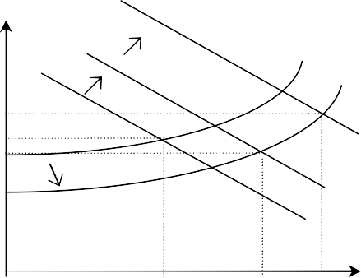

CD(2)

CD(3)

CD(1)

CS(1)

A

CS(2)

F

E

*il(1)*

*il(2)*

1997 1999 2001 2003 2005 2007

Note: (a) number of mentions on ‘money’ in ‘Immediate policy decision’ section of MPC *Minutes*

Source: Bank of England

C1 C2

C3 Credit

# Diagram B: Shift in supply of credit (CS(1)→ CS(2)), unchanged demand (CD)

*iloan*

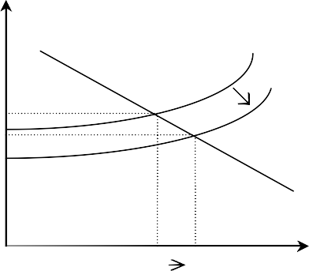

CD

CS(1)

A

B

CS(2)

C1

C2

Credit

*il(1)*



*il(2)*

# Chart 2: Total credit to UK households

£ billions

1600

Total lending to individuals

Bank and building society cred it

1400

1200

1000

800

600

400

200

0

# Chart 3: Total credit to UK private non­financial companies

1987 1991 1995 1999 2003 2007

Source: Bank of England, ONS

# Chart 4: Shares of total lending to UK households

£ billions

4000

**Total financial liabilitie s**

**Total lending to**

**PNFCs**

**PNFCs' M4L**

3500

3000

2500

2000

1500

1000

500

0

Non­bank lending Bank lending

Percen tage of total lending to households

100

|  |  |  |  |  |  |  |  |  |  |  |  |  |  |  |  |
| --- | --- | --- | --- | --- | --- | --- | --- | --- | --- | --- | --- | --- | --- | --- | --- |
|  |  |  |  |  |  |  |  |  |  |  |  |  |  |  |  |

90

80

70

60

50

40

30

20

10

0

1987 1991 1995 1999 2003 2007

Source: Bank of England, ONS

1993 1997 2001 2005

Source: Bank of England, ONS.

# Chart 5: Securitisations relative to stock of M4 lending

**Chart 6: UK household sector asset­ backed security spreads**

Percentage of sectoral M 4L s tock

25

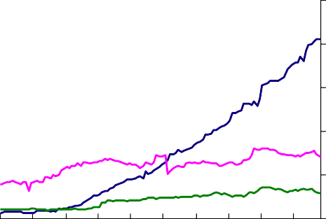

Household secured

Household unsecurd

PNFCs

20

15

10

5

Basis points 400

350

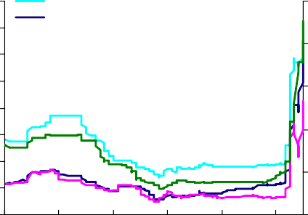

**Commercial mortgages**

**Credit cards**

**ages**

**Prime mortg**

**Non­conforming mortgages (LHS )**

300

250

200

150

100

50

0

Basis points

150

120

90

60

30

0

0

98 99 00 01 02 03 04 05 06 07

Source: Bank of England

2002 2003 2004 2005 2006 2007

Source: LehmansLive

Note: weighted averages of AAA, AA, A and BBB 5­ years spreads for prime and commercial mortgages and of AAA, A and BBB 5­year spreads fro credit cards and non­confirming mortgages.

# Chart 7: Spread of effective mortgage and personal loan rates (new business) to Bank Rate

**Chart 8: UK corporate bond spreads**

Per cent

6

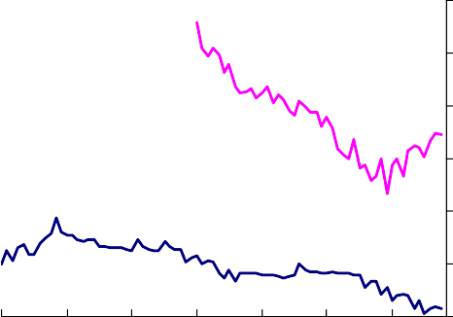

P erson al loans

M ortgages

5

4

3

2

1

0

2001 2002 2003 2004 2005 2006 2007

Source: Bank of England

1998 2000 2002 2004 2006

Source: Bloomberg, Bank of England

Basis Points

1200

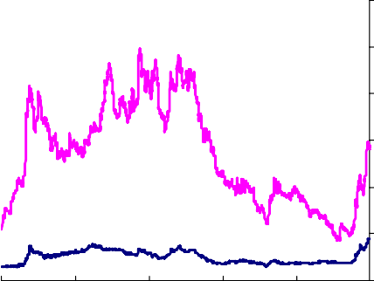

Non­invest ment grade

Invest ment grade

1000

800

600

400

200

0

# Chart 9: Decomposition of UK non­ investment grade corporate bond spreads

**Chart 10: Issuance of UK residential mortgage­backed securities**

s points

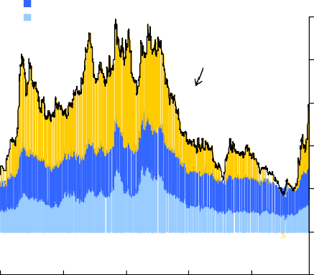

Residual including liquidity Uncertaint y about default loss Expect ed default lo ss

Basi

**Actual**

1000

800

600

400

200

£ blns

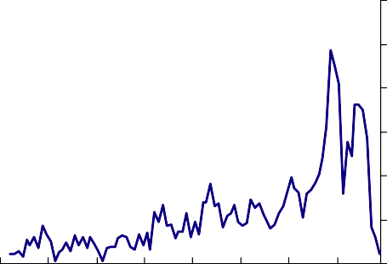60

50

40

30

20

10

1998 2000 2002 2004 2006

Source: Bloomberg, Bank of England

0

­200

0

2000 2001 2002 2003 2004 2005 2006 2007

Source: Dealogic

# Chart 11: Gross corporate bond issuance by UK private non­financial companies (all currencies)

**Chart 12: Basis between credit spreads on bonds and credit default swaps**

£, billions

12

10

8

basis points

150

Europe

US

100

50

6

4

2

0

2003 2004 2005 2006 2007

Source: Bank of England

Jan. Apr. Jul. Oct . Jan. Apr. Jul. Oct.

Source: JP Morgan Chase & Co and Merrill Lynch.

0

­50

­100

­150

­200

­250

# Chart 13: Global capital issuance by tier

1. The difference between: US CDX crossover index and a BB rated US corporate bond index; and European iTraxx crossover index and a European BB­B rated corporate bond index. This is because the iTraxx crossover index has a lower average rating than the CDX crossover.

$ billions

Lower T 2

Upper T 2

T 1 ( incl hybrid capital)

50

40

30

20

10

Jan

2005

May

Sep

Jan

2006

May

Sep

Jan

2007

May

0

Sep

Source: Dealogic

# Chart 14: UK mortgage approvals Chart 15: UK net secured lending to

**households**

2001 2003 2005 2007

Source: Bank of England

nds 100

90

**Top 5 banks by market capitalisation** Thousa

**O ther banks and lenders Building societies**

80

70

60

50

40

30

20

10

0

2001 2003 2005 2007

Source: Bank of England

llions 8000

6000

**Top 5 banks by market capitalisation** £ mi

**O ther banks and lenders Building societies**

4000

2000

0

# Diagram C: Shifts in supply of credit (CS(1)→ CS(2)) and money supply

*iloan*

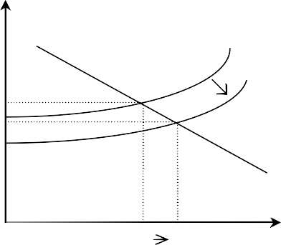

CD

CS(1)

A

B

CS(2)

C1

C2

Credit

*il(1)*

*il(2)*

*iwholesale*

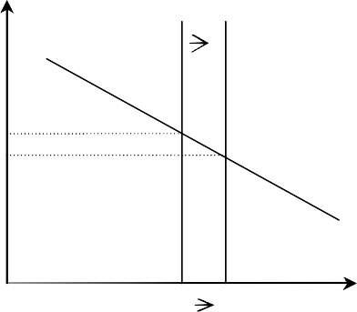

MD

MS(1)

MS(1)

A’

B’

M1

M2

Money

*iw(1)*

*iw(2)*

# Chart 16: Lenders’ margins on UK mortgages

Basis point s Basis point s

140

120

100

80

60

40

20

600

500

P ersonal loans (RHS)

Mortgages (LHS)

400

300

200

100

0 0

1999 2001 2003 2005 2007

Source: Bank of England

Note: spreads of effective rates on stocks of lending over appropriate funding costs.

# Chart 17: UK wholesale M4 growth Chart 18: 10­year rolling averages of

**UK broad money growth and inflation**

% change on a year ago

40

35

30

25

20

15

10

5

0

­5

­10

1987 1990 1993 1996 1999 2002 2005

Source: Bank of England

% average annual growth

20

Broad money

CPI

1880 1900 1920 1940 1960 1980 2000

15

10

5

0

­5

Source: Capie, F and Webber, A (1985), ‘A monetary history of the United Kingdom, 1870­1982’, and ONS.

# ENDNOTES

1 ‘The transmission mechanism of monetary policy’, a paper by the Monetary Policy Committee at the Bank of England, April 1999 and Harrison R., K. Nikolov, M. Quinn, G. Ramsay, A Scott and R. Thomas, ‘The Bank of England Quarterly Model’, Bank of England 2005. The Bank’s wider ‘suite of models’ does include richer asset price channels.

2 Stiglitz, J. E. and A. Weiss (1981), ‘Credit rationing in markets with imperfect information’, *The American Economic Review,* Vol. 71, No. 3, pp 393­410.

3 Bernanke, B. and M. Gertler (1989), ‘Agency cost, net worth, and business fluctuations’, *The American Economic Review*, March 1989, pp 14­31.

4 See Churm R., and L. Webber (2007), ‘Decomposing corporate bond spreads’, Bank of England

*Quarterly Bulletin,* Q4 2007 (forthcoming).

5 Alan Greenspan made this point a few times.

6 For example see Tucker P M W (2007), ‘A perspective on recent monetary and financial system developments’, speech at Merrill Lynch Conference on Hedge Funds, Bank of England Quarterly

Bulletin, Q3 2007, pp 310­16.

7 Adrian, Tobias, and H. S. Shin (2007), ‘Liquidity, Monetary Policy and Financial Cycles’, paper prepared for *Current Issues in Economics and Finance*. Adrian, Tobias and H S Shin, (2007), ‘Liquidity and Financial Cycles’, paper presented at the 6th BIS annual conference on “Financial System and Macroeconomic Resilience”. Analytically, the argument, *as summarised in the main text*, needs to be supplemented with a mechanism that somehow impedes checks and balances from preventing the overshooting of fundamentals.

8 Loutskina E. and P. E. Strahan (2006), ‘Securitisation and the declining impact of bank finance on loan supply: evidence from mortgage acceptance rates’, National Bureau of Economic Research

(NBER) *Working Papers*, No. 11983. And Estrella, A. (2002), ‘Securitization and the efficiacy of monetary policy’, *Economic Policy Review*, Vol. 8, No.1.

9 For an overview of early work see Kashyap, A. K. and J. C. Stein (1994),’Monetary policy and bank lending’, in G. N. Mankiw, ed., Monetary policy, *Studies in Business Cycles*, vol. 29. pp. 221­56.

10 In a Modigliani­Miller world of perfect capital markets, a bank’s overall cost of funds is independent of its capital and funding structure. As a result the level of bank capital and the balance of wholesale and retail funding are not relevant to bank lending decisions and so do not affect the monetary transmission mechanism.

11 Bernanke, B. S. and C. S. Lown (1991), ‘The credit crunch’, *Brookings Papers on Economic Activity*, No. 2, pp. 204­39.

12 Ashcraft, A. B., and M. Campello (2002), ‘Borrowers' financial constraints and the transmission of monetary policy: evidence from financial conglomerates’, Federal Reserve Bank of New York, Staff Reports: 153.

13 Akerlof, G. A. (1970), ‘The market for ‘lemons’: quality uncertainty and the market mechanism’,

*Quarterly Journal of Economics*, Vol. 84, No. 3, pp. 488­500. A market for ‘lemons’ issue arises when informational deficiencies give rise to uncertainty about the true quality of a product. In such circumstances, buyers choose to pay only average prices for goods that carry the risk of sellers overstating their true quality. As a result, sellers of good products, having little incentive to participate in such markets, are driven out by those sellers of poor quality products. The most common example of the problem is the market for used new cars. Rationing in the interbank markets is discussed by Freixas, X. and J. Jorge (2007) in ‘The role of interbank markets in monetary policy: a model with rationing’, Universitat Pompeu Fabra, *Economics Working Papers*.

14 Kashyap, A. K. and J. C. Stein (2000), ‘What do a million observations say about the transmission of monetary policy’, *The American Economic Review*, Vol. 90, No. 3, pp. 407­28.

15 See Kashyap, A. K., R. Rajan and J. C Stein (2002), ‘Banks as liquidity providers: an explanation for

the coexistence of lending and deposit­taking’, *The Journal of Finance*, Vol. 57, No. 1, pp 33–73.

16 Acharya, V. V., H. S. Shin and T. Yorulmazer (2007), ‘Fire sales, foreign entry and bank liquidity’,

*C.E.P.R Discussion Paper*, No. 6309.

17 See Goodhart, C. A. E. (2007), “Whatever Became of the Monetary Aggregates?”, Peston Lecture at Queen Mary College, London; King M. A. (2007), ‘The MPC ten years on’, lecture to the

Society of Business Economists, Bank of England *Quarterly Bulletin*, Summer 2007, pp 272­85; and Tucker P. M. W. (2007), ‘Central banking and political economy: the example of the UK’s Monetary Policy Committee’ speech at the Inflation Targeting, Central Bank Independence and Transparency Conference, Cambridge, Bank of England *Quarterly Bulletin*, Autumn 2007, pp445­52.

18 There is an echo here of a channel stressed by Brunner & Melter, but with the impulse coming from the central bank’s short­term interest rate rather than the quantity of reserves, and the transmission into risk premia and so other asset prices coming via the expected path of the policy rate and broad money rather than via narrow money.

19 Perhaps nothing illustrates this as cleanly as the advent of credit derivatives. Derivatives of any kind unbundle funding (and so liquidity risk) from the underlying risk to which an agent is seeking exposure via a particular contract. So a credit derivative unbundles credit risk from funding. This further complicates interpretation of the bank lending data (M4L). Imagine that, due to their customer networks and screening capability, banks originate all credit, but that they use credit­default swaps to shed a great portion of the credit risk via CDS to non­bank financial institutions. In the limit, this would be a world in which M4L correctly measured (bank) lending and M4 was one useful measure of

‘liquidity’. But it would also be a world in which shocks to credit conditions from capital and risk appetite worked largely through non­bank lenders, and in which shocks to liquidity worked largely through depositor confidence in the banking system. In the real world, this story underlines the need to look at total credit, and to analyse the monetary data with finesse.

20 See Bank of England *Inflation Report*, November 2007, Section 1 on ‘Money and Asset Prices’, pages 16­17.

21 “…households have increased their debt….more debt unavoidably leaves them more vulnerable to bad luck, eg adverse economic shocks”, Tucker, P. M. W. (2003), ‘Credit conditions and monetary policy’, speech at the Leeds Financial Services Initiative, Bank of England *Quarterly Bulletin*, Autumn 2003, p. 373.

22 I argued this in Tucker, P. M. W. (2006), ‘Reflections on operating inflation targeting, speech at the Chicago Graduate School of Business, Bank of England *Quarterly Bulletin*, Summer 2006, p. 220.